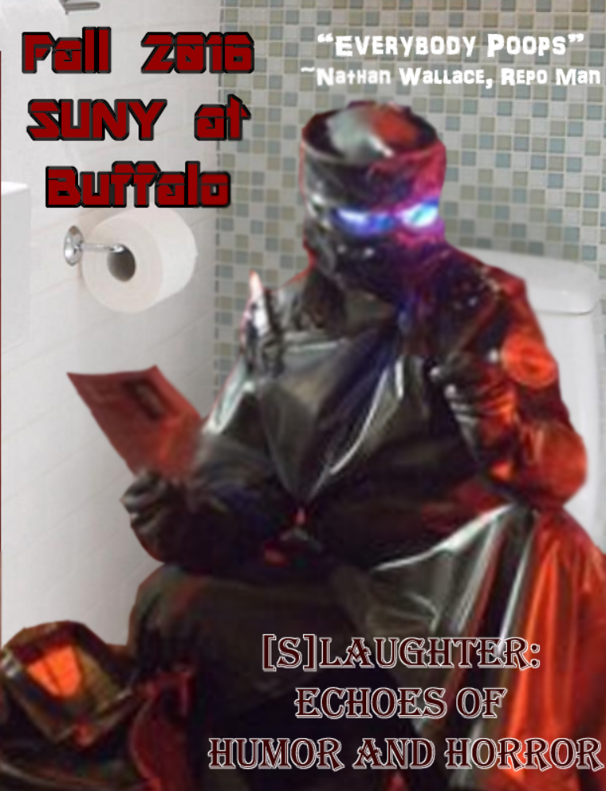
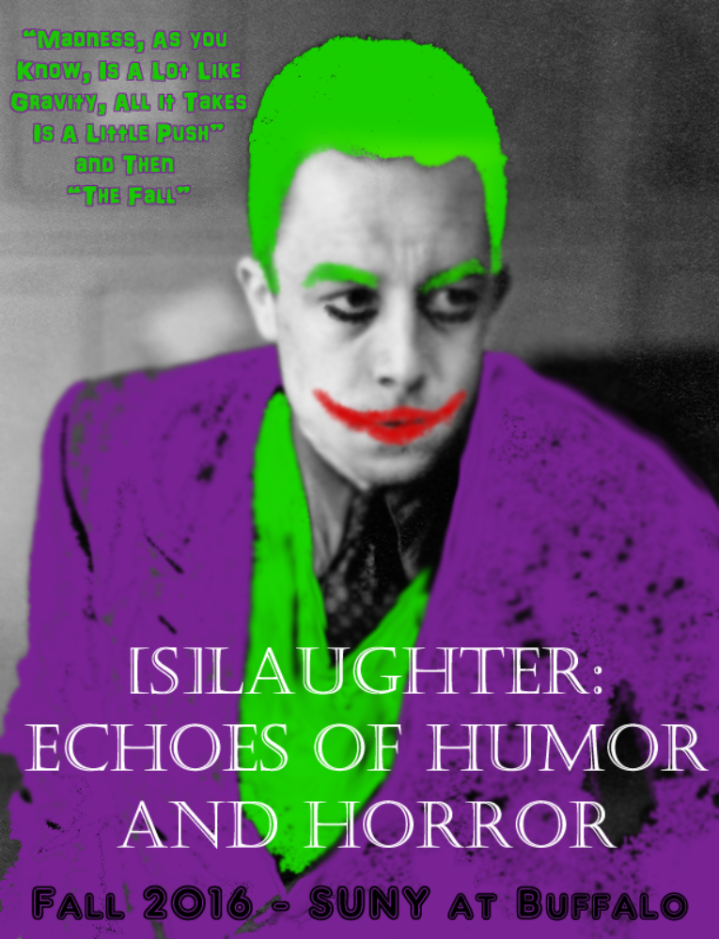
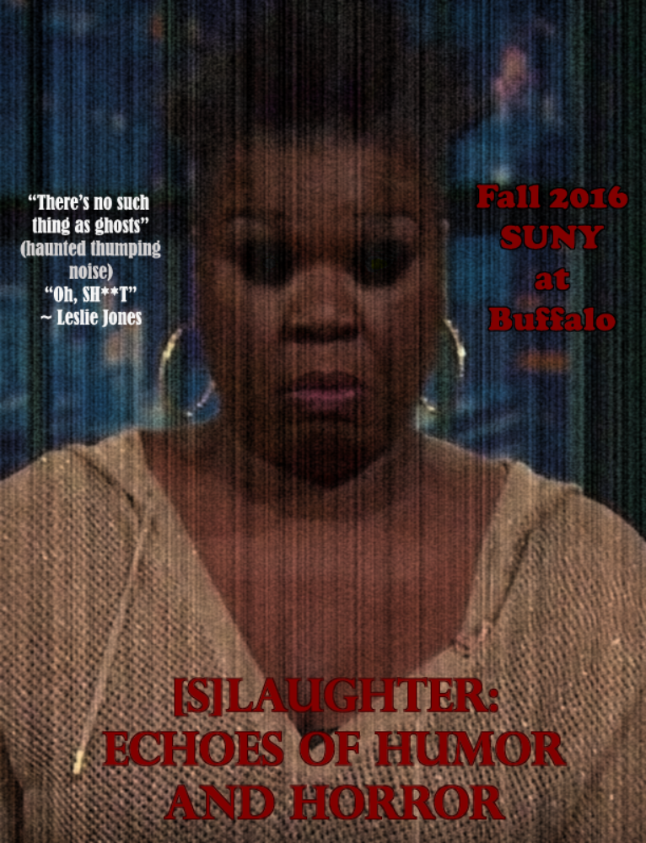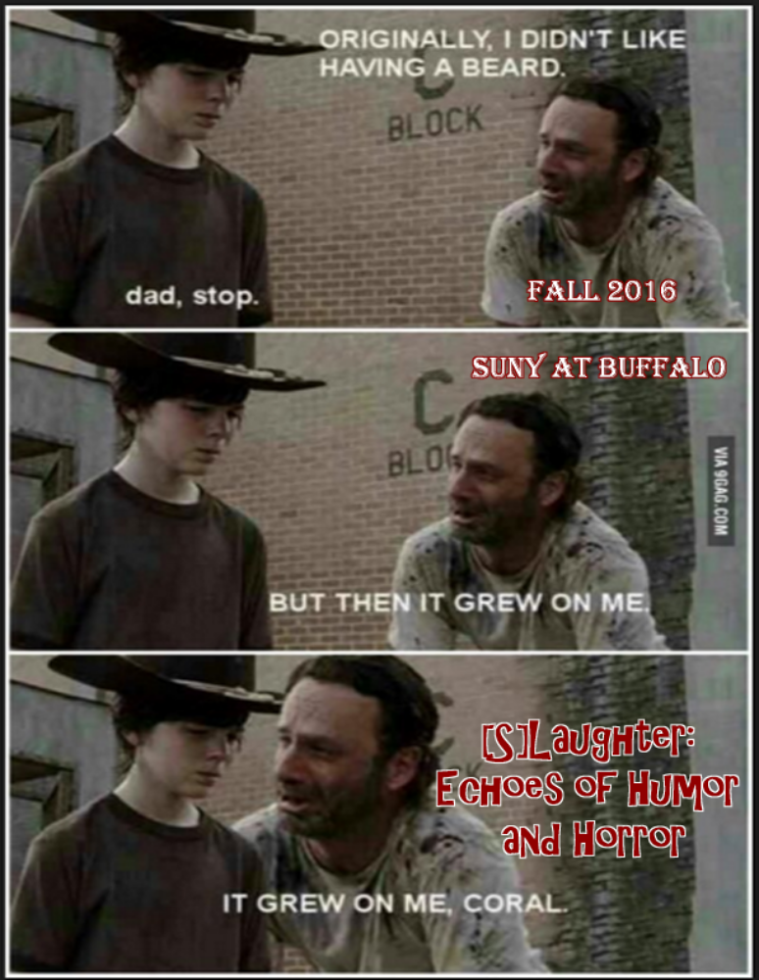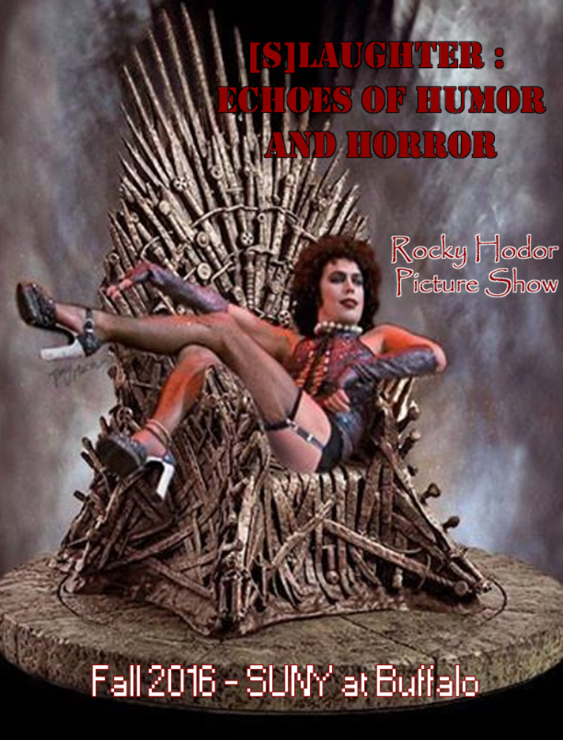

Call for Papers:

“[S]laughter: Echoes of humor and horror”

The Third Annual Undergraduate Student Symposium of Popular Culture and Philosophy
Hosted by the State University of New York at Buffalo Department of Comparative Literature Graduate Student Association
Keynote Speaker: David Schmid
Friday, October 28th, 2016, 9 a.m.- 5 p.m.
<<<<
“Why so serious?” ~The Joker – The Dark Knight

The line between good and evil is extremely complicated. Philosophers have debated its nature for centuries. If good is really so good, then why is evil so tempting? It is easy to find humor in the misfortune of others, and as such, humor and horror are intrinsically tied. The echoes of sinister laughter are embedded deep into our culture from The Astronomer and the Well to La Chute (Camus’ The Fall) and even popular films (The Dark Knight). Why is dark humor so appealing? What about humor’s very nature is dark?
This symposium will explore the role of humor and horror in culture, art, literature and philosophy. Whether discussed individually or separately, many of the points of discussion will overlap. The goal of this conference is to shed light on the lighter and darker sides of humanity, with the hopes of demonstrating that joy and terror do not always exist in a binary. As a symposium of popular culture and philosophy, we engage with questions of philosophy, as well as the human rights. As always, we encourage submissions related to popular culture.

Possible topics include but are not limited to:

- Serial Killer Culture
- Stand-up Comedy
- Dark humor
- Film, music and art in the genres of horror and/or comedy
- B-grade Horror and Comedy/Cult Films
- Comic book culture
- The philosophy of humor
- Unintentional comedy in horror
- Performance and audience
- Violence and comedy
- Thrillers and mind-benders
- Riddles and puzzles
- Fear and terror
- Cultural notions of laughter and horror

We invite submissions for papers focusing on works of literature, popular culture, philosophy and theory.
Presentations should be in English and should not exceed twenty minutes. Presentations will be considered for a digitally published, peer-reviewed undergraduate journal.

Please send abstracts of 150-250 words by email to UBCOLsymposium@gmail.com, or submit a printed copy at 634 Clemens by Friday, September 30th, 2016.

Proposals should include your paper title, name, contact information, and institutional/departmental affiliation (university and major).

Round-Table Discussion: Students are invited to send a 4-5 sentence proposal for a round-table discussion that they will lead. Round-table presentations will take from 5-15 minutes and discuss a topic related to the conference in a panel of peers, including at least one graduate moderator. A discussion will follow, allotting 30 minutes per topic.

Call for Creative Endeavors:
“[S]laughter: Echoes of humor and horror”
in conjunction with
The Third Annual Undergraduate Student Symposium of Popular Culture and Philosophy
Hosted by the State University of New York at Buffalo Department of Comparative Literature GSA
Friday October 28th Keynote Speaker: David Schmid
Saturday, October 29th and Sunday, October 30th, 2016

For the first time ever, the SUNY Buffalo Comparative literature GSA would like to present a creative extension to its undergraduate symposium, open to graduate students and undergraduate students alike. Over the past several years we have continually expanded this symposium, reaching a large academic audience. We wish to further expand! One of the benefits of being a Comparative Literature program is that we have a responsibility to be truly multidisciplinary. As a result, we are looking for creative works (art, poetry, performance art, music, etc.) fitting the scope and general tone of our undergraduate symposium.
The symposium will explore the role of humor and horror in culture, art, literature and philosophy. Whether discussed individually or separately, many of the points of discussion will overlap. The goal of this conference is to shed light on the lighter and darker sides of humanity, with the hopes of demonstrating that joy and terror do not always exist in a binary. As always, we encourage submissions related to popular culture and/or philosophy.

The submission guidelines are as follows:
Day 1 (October 28th: Art and Critique)

All submissions must be accompanied by a partner who will provide a 10 minute academic analysis or contextualization of the submitted work, and place it within the framework of the conference. Submissions with concrete evidence of existence (audio/video/image files) will be considered before abstracts. An academic abstract is not required, but the name of the critic and their relevant institution is necessary. We do encourage partnerships across universities and would be glad to circulate a request for a critic here at UB. These works must be 3-10 minutes in length. (Combined presentation of approximately 20 minutes. 10 minutes will be allotted for Q&A.)

Art/Visual/Media Performance:
An image/series of images/the intended media must be submitted via e-mail. If the work does not yet exist, a description of the intended project must be submitted, along with a description of its importance to this type of event. Abstract: 250-500 words.

Poetry/Other Reading:
Please submit a selection of your work (approximately ½ page for prose poems, 1 page for other formats) that gives us a sense of your project. If the project is ‘in progress’ please explain the intended scope of your project and why it is relevant to this Symposium. Abstract: 250-500 words.

Video/Music/Dance/Other Performance:
Please submit a recorded sample, particularly in the case of music. We will accept abstracts in this category, but they must be extremely well defined if they will be considered. Abstract: 250-500 words.

Day 2 (October 29th: Creative Celebration)

Requirements are the same as the previous day, except we do not require academic collaboration. Participants will be allowed up to 20 minutes for performance. There will also be 2 hours of spontaneous art in the late afternoon/evening (depending upon the number of submissions). If you would like to participate in this event, please let us know.

Participants are welcome to participate in any portion of the event, but we offer our guest graduate students the unique opportunity to serve as moderators for the Friday undergraduate symposium, as the presentation of papers is intended for undergrads. (You can list this on your C.V. as guest moderator. We don’t mind!)

We cannot provide financial support to travelling graduate students. For that, you have our apologies. As a Graduate Student organization, most of our funds must be allotted to graduate student ‘only’ events and as such the budget for this type of event is somewhat limited. We assure you, however, that David Schmid’s talk is worth your travel and that you will find welcoming and exciting peers here at UB.

Admission/registration for this event is free and it is open to the public.

All submission will be judged subjectively, based on personal interest and academic relevance, as is typically the case with these types of events (whether it is explicitly stated or not).

We do intend to take photographs and make audio/visual recordings for the department archives. There will be a waiver presented at the event. Should you choose not to be recorded, we would prefer advanced notice.

Please send abstracts/samples by email to UBCOLsymposium@gmail.com by Friday, September 16th, 2016. The conference coordinator is David Brown, should you have any questions.

Proposals should include the name of your project, your name, contact information, and institutional/departmental affiliation (university and major).

Meals will not be provided on Saturday and Sunday. We will provide some simple breakfast options and lunch on Friday.

